Day 1: GitHub Copilot + Azure Static Web App

Prerequisites
Azure tenant: Azappsqltrainoutlook.onmicrosoft.com
Example: When logging into Azure AD, the domain shows as Azappsqltrainoutlook.onmicrosoft.com

Azure subscription: Azappsqltrain subscription 1
Example: In the Azure portal, you’ll see “Azappsqltrain subscription 1” listed under subscriptions.

Resource group: Labuser0x-RG
Example: Resource group created for lab participants to host demo resources.

Open Microsoft Edge In New InPrivate Window:
Login to Url: https://portal.azure.com/

Login to portal with username and password provided:
Example: Labuserxx@Azappsqltrainoutlook.onmicrosoft.com

Go to New tab and login with below URL (copy paste URL)
Note : user has to login with the provided username and password
Example: Labuserxx

Login to Below Github URL:

GitHub Enterprise: https://github.com/enterprises/Azsqlapp-inc/sso
Example: Enterprise banner visible: Users managed by Azsqlapp-Org
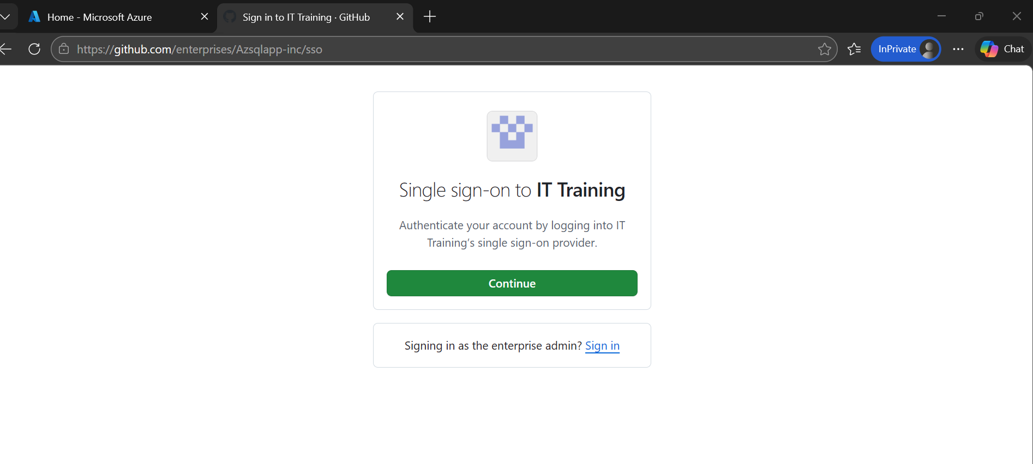

Click on open user navigation menu

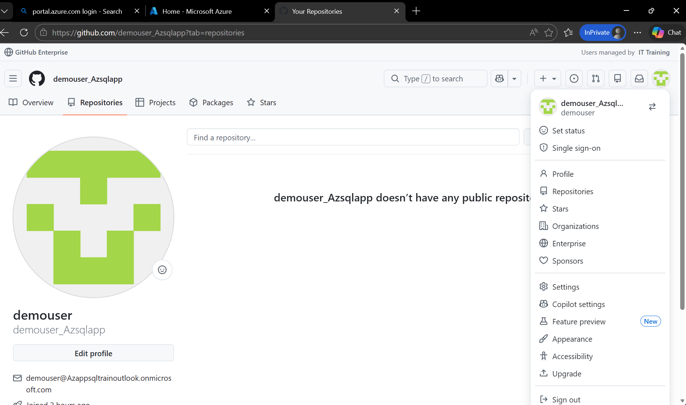

Click on Repositories and create new Repositories

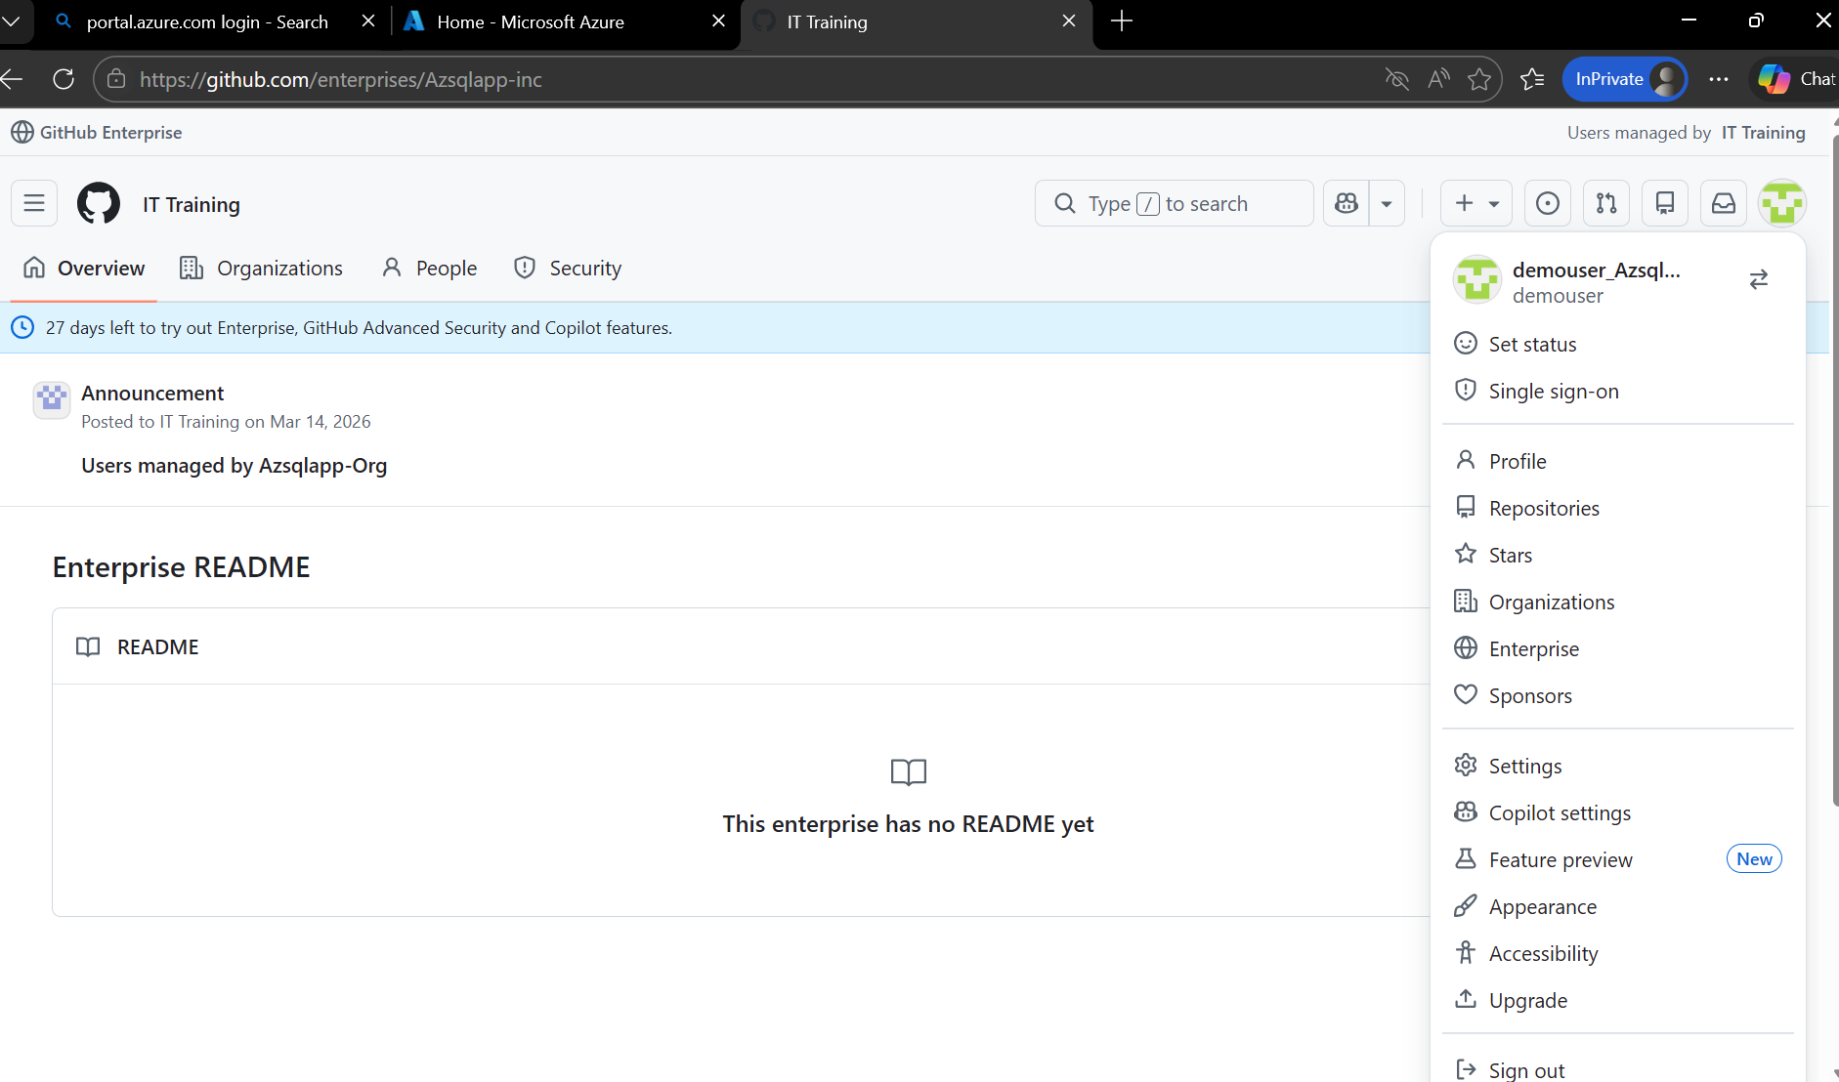

Go to Owner and select the Username_Azsqlapp
Example: Labuserxx_ Azsqlapp.

Type Repository name: Labuserxx repository

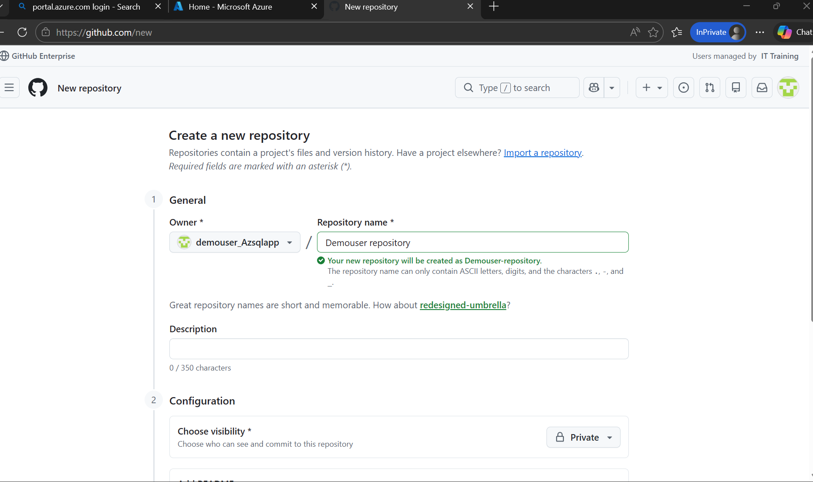
Lab

Scroll down and go to Add README select On and click on create repository

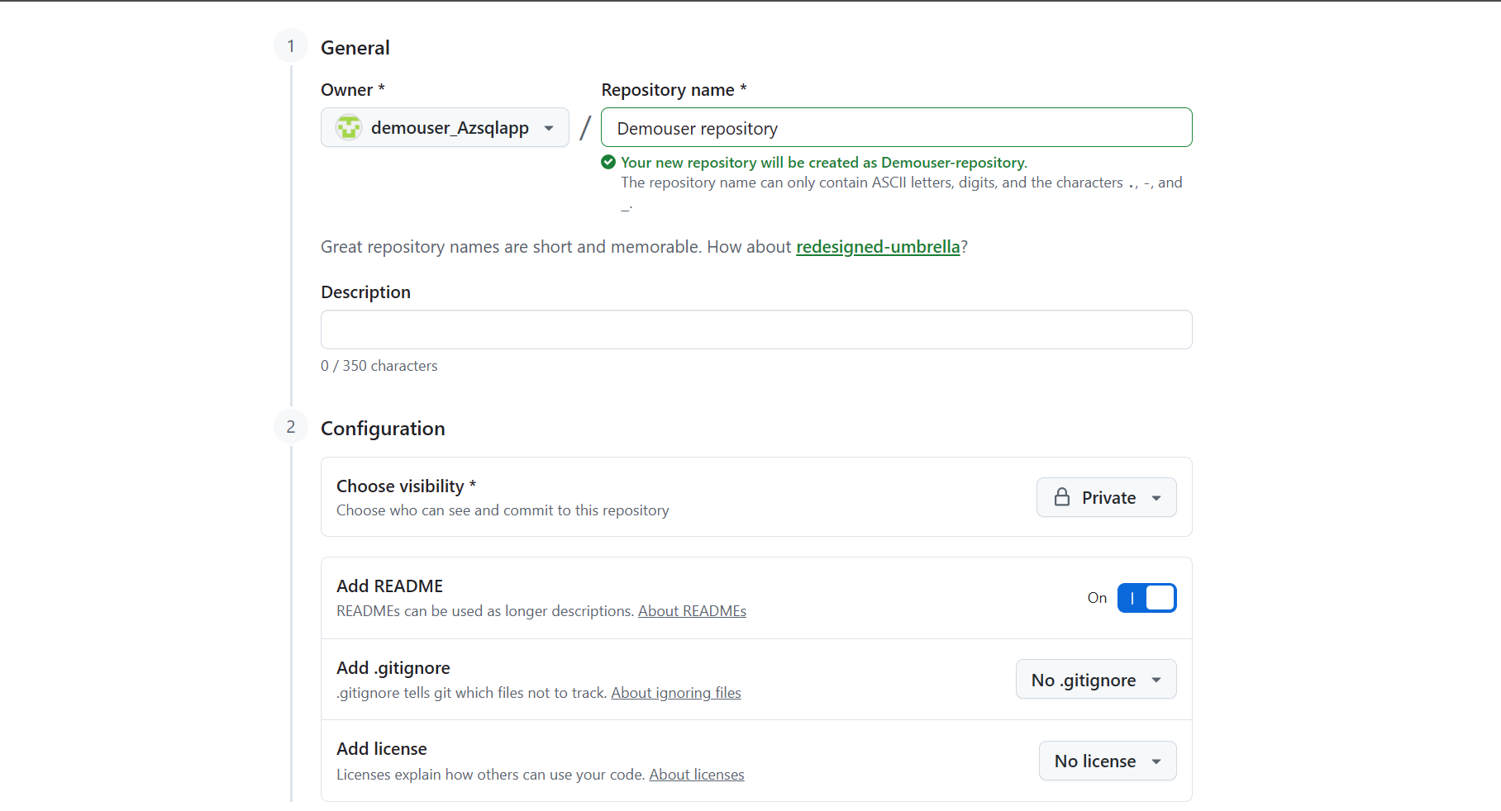

Your new repository is created now

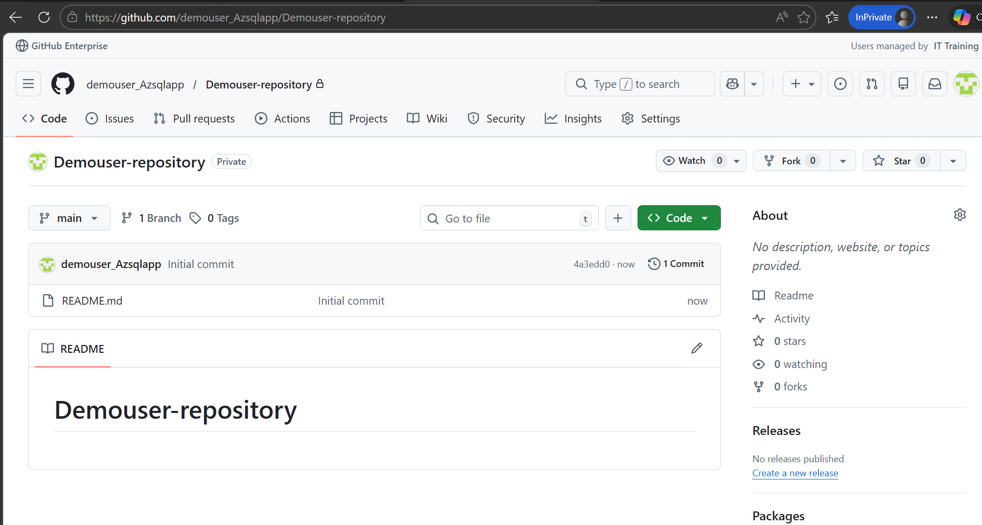

Go to Azure portal and search for Static Web Apps 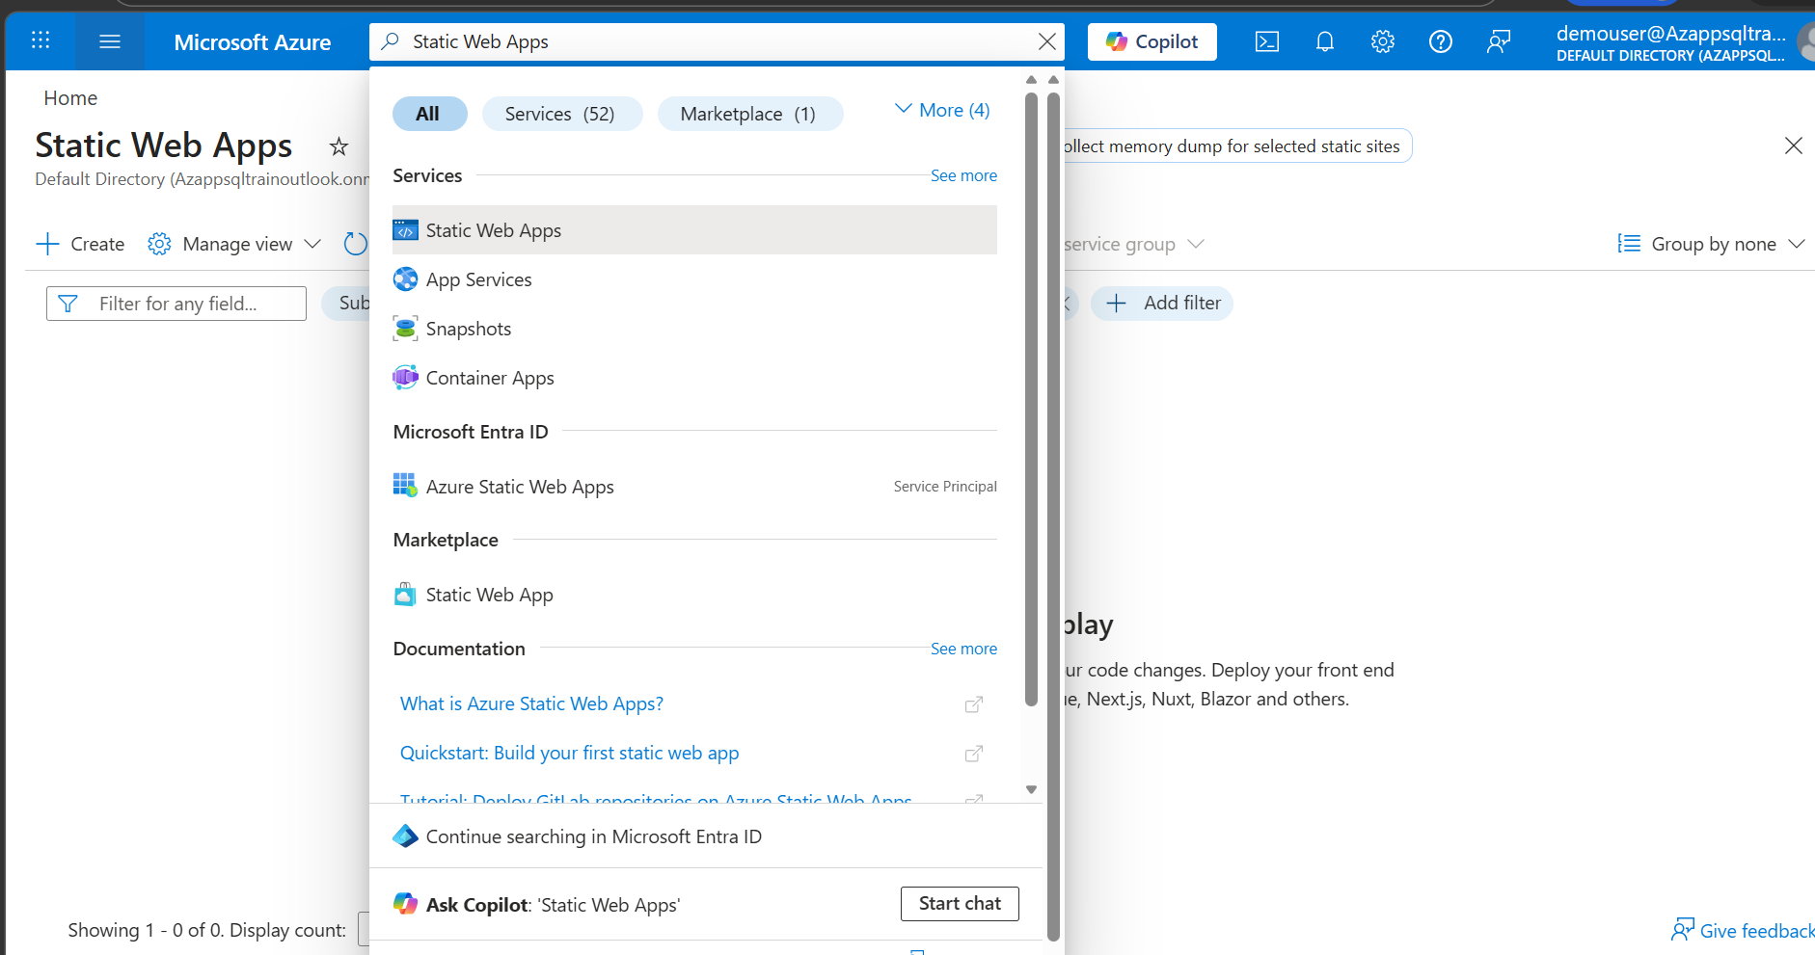

Click on Create Select Subscription and Resource Group provided by Lab instructor

Enter Static Web App details name : my-first-static-web-app-<Username>

Example : my-first-static-web-app-labuserxx

Plan type: Free: For hobby or personal projects
Deployment details Source: Github
Select Organization: demouser_Azsqlapp

Select Repository: Demouser-repository
Select main: main
Build Presets: Select a framework

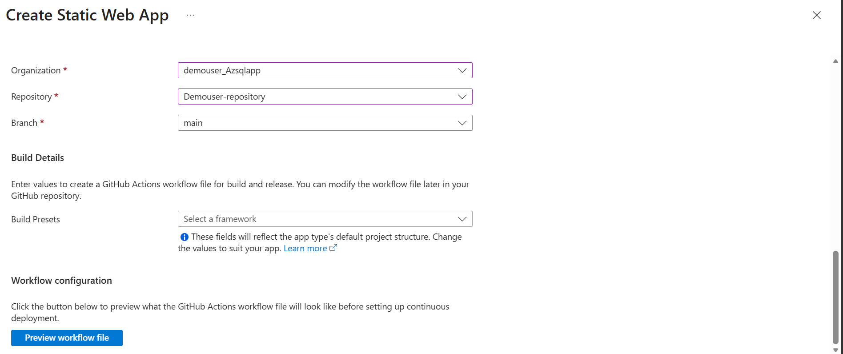

Click Review + create

Github:

Go to Github repositories:

Confirm GitHub Action
Workflow file created in repo
Action run succeeds
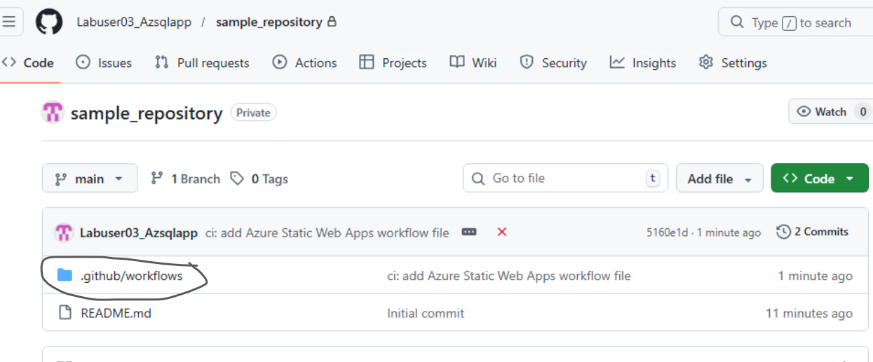

Azure portal shows app status Ready
Example: GitHub Actions tab shows green checkmark for “Azure Static Web Apps CI/CD.”
Validate published URL
Example URL: gentle-desert-0fc84fc1e.6.azurestaticapps.net
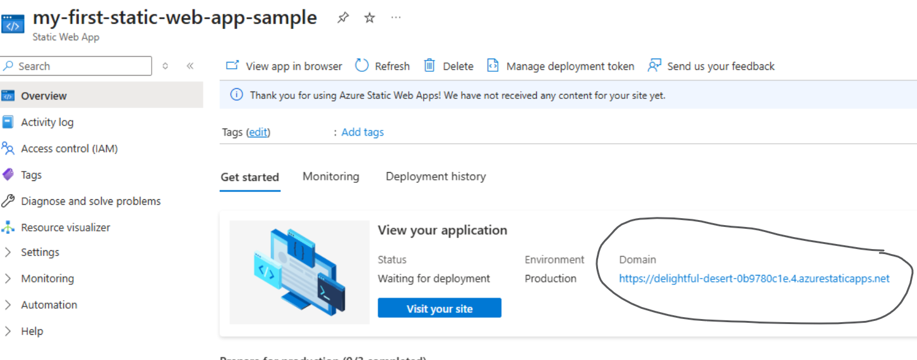

Example: Opening the URL shows the default “Congratulations on your new site! ” page.
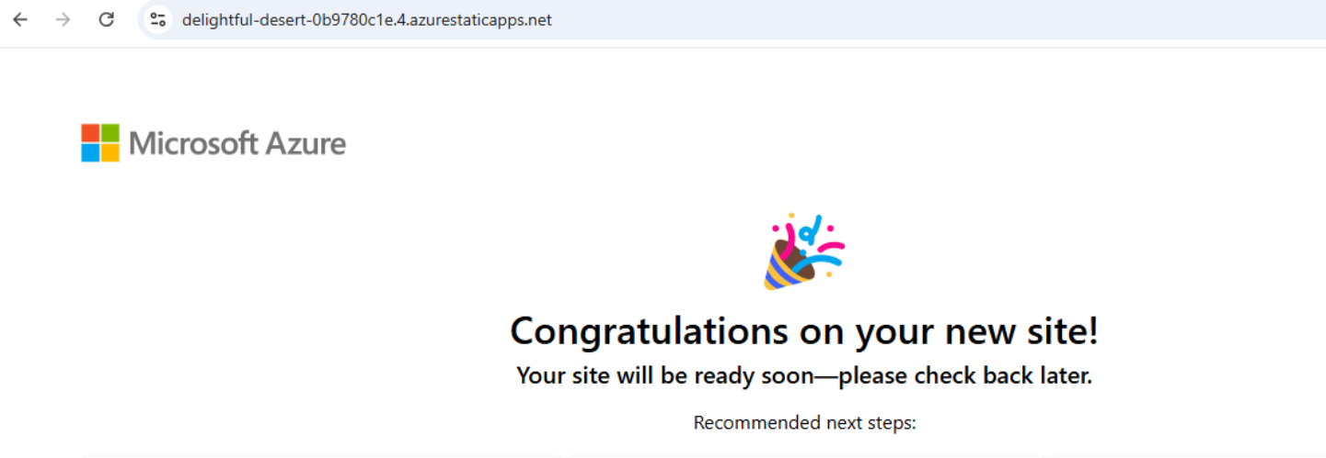

Modify code with Copilot
Edit index.html or app.js
Copilot: suggest change (title/button)
Manual fallback: update title, add button, commit

Push to main → Action redeploys
Example: Copilot suggests changing <h1>Hello World</h1> to <h1>Hello Contoso Labs!</h1>.

Verify deployment
Refresh app URL
Confirm changes live
Example: Browser now shows “Hello Contoso Labs!” with a new button.
Document results
Update README.md with steps, screenshots, URL
Commit: “Day 1 demo: Copilot + Azure Static Web App”
Example: Repo commit history shows the documentation update.

Code: HTML/CSS/JS app
index.html
<!doctype html>
<html>
<head>
<meta charset="utf-8">
<title>My wonderful website</title>
<link rel="stylesheet" href="css/style.css">
</head>
<body>
<h1>Welcome to my wonderful website</h1>
<p>You will never find another place as cool as this</p>
<p><img src="img/bridge.jpg" alt="A nice picture of The Bridge"/></p>
</body>
</html>

Example GitHub Workflow (.github/workflows/azure-static-web-apps.yml)
This file is automatically created when you connect your repo to Azure Static Web Apps, but here’s a simplified example:
name: Azure Static Web Apps CI/CD

on:
push:
branches:
- main
pull_request:
types: [opened, synchronize, reopened, closed]
branches:
- main

jobs:
build_and_deploy_job:
runs-on: ubuntu-latest
name: Build and Deploy Job
steps:
- uses: actions/checkout@v2
- name: Build And Deploy
uses: Azure/static-web-apps-deploy@v1
with:
azure_static_web_apps_api_token: ${{ secrets.AZURE_STATIC_WEB_APPS_API_TOKEN }}
repo_token: ${{ secrets.GITHUB_TOKEN }}
action: "upload"
app_location: "/"
api_location: ""
output_location: "/"

How it works
The HTML file displays the heading and button.

